OIL CONDITION MONITORING REPORT SLNS SAYURA

GEAR BOX PARTICULARS (Information provided by the customer)
 | Port Gear Box (No.02)
Make : | Renktack
Model : | ASL 69 GMBH
Sr.No’s: | 641181
Sampling Date | 12 May 25
Sampling point : | Lube oil sump
Sampling Method : | Extraction
Type of Lubricant : | Shell Gadinia S3 40
System Capacity : | 450 Ltrs

RUNNING HRS DETAILS (Information provided by the customer)
 | Port Gear Box (No.02)
Sample ID | M010166
Oil Running Hours | 1931.10
Total Running Hours of the Machinery | 49930.35

ANALYSIS RESULTS
Viscosity
Description | ASTM Method | Fresh Oil  (As per OEM data sheet) | Uncertainty  (K=2) | Port Gear Box  (S/I-M010166)
Viscosity @ 40ºC (cSt) | ASTM D 445 | 128.00 | 0.006 | 106.82
Viscosity @ 100ºC (cSt) | ASTM D 445 | 13.70 | 0.005 | 12.14
Viscosity Index | ASTM D2270 | 103 | N/A | 103.73

Elemental Concentration as per ASTMD 5185 (ppm)

Element | Maximum Permissible Limit | Fresh Oil Sample | Uncertainty  (K=2) | Port Gear Box  (S/I-M010166)
Fe | 300 | < 1.000 | 0.15 | 12.465
Cr | 15 | < 1.000 | 0.18 | < 1.000
Si | 50 | < 1.000 | 0.17 | < 1.000
Al | 30 | < 1.000 | 0.28 | < 1.000
Pb | 1500 | < 1.000 | 0.13 | 17.614
Cu | 250 | < 1.000 | 0.17 | 5.993
Sn | 50 | < 1.000 | 0.20 | < 1.000
Ni | 30 | < 1.000 | 0.08 | < 1.000
N/A – Not Available

TREND ANALYSIS WITH PREVIOUS REPORTS

 |  | Fresh Oil Sample | Port Gear Box
 |  | Fresh Oil Sample | S/I-M000086 | S/I-M000777 | S/I-M002383 | S/I-M002851 | Fresh Oil Sample | S/I-M006304 | S/I-M006714 | S/I-M010166
Oil Running Hrs |  | - | 2723.15 | 3325.35 | 4839.00 | 5000.00 | - | 1008.05 | 1214.20 | 1931.10
T/R/H of Machinery |  | - | 45637.45 | 46201.15 | 47753.30 | 47956.20 | - | 48964.25 | 49131.00 | 49930.35
Basic Properties-
Viscosity @ 40ºC (cSt) |  | 139.00 | - | 136.56 | 135.20 | 134.14 | 128.00 | 124.85 | 126.24 | 106.82
Viscosity @ 100ºC (cSt) |  | 14.40 | - | 14.06 | 13.74 | 13.74 | 13.70 | 13.36 | 13.76 | 12.14
Viscosity Index |  | 103 | - | 99.75 | 97.21 | 98.04 | 103 | 102.33 | 105.63 | 103.73
Element | Max. Permissible Limit
Fe | 300 | < 1.000 | 8.910 | 24.141 | 7.280 | 7.926 | < 1.000 | 12.946 | 8.793 | 12.465
Cr | 15 | < 1.000 | < 1.000 | < 1.000 | < 1.000 | < 1.000 | < 1.000 | < 1.000 | < 1.000 | < 1.000
Si | 50 | < 1.000 | 1.486 | 5.732 | 2.536 | 2.616 | < 1.000 | 5.025 | 6.577 | < 1.000
Al | 30 | < 1.000 | 3.287 | 2.267 | < 1.000 | < 1.000 | < 1.000 | < 1.000 | 3.471 | < 1.000
Pb | 1500 | < 1.000 | 17.878 | 16.813 | 14.85 | 33.995 | < 1.000 | 43.909 | 26.528 | 17.614
Cu | 250 | < 1.000 | 5.349 | 6.436 | 2.154 | 2.091 | < 1.000 | 6.120 | 6.626 | 5.993
Sn | 50 | < 1.000 | 2.156 | < 1.000 | < 1.000 | < 1.000 | < 1.000 | < 1.000 | < 1.000 | < 1.000
Ni | 30 | < 1.000 | - | < 1.000 | < 1.000 | < 1.000 | < 1.000 | N/A | N/A | < 1.000
Wear Metals
Port Gear Box
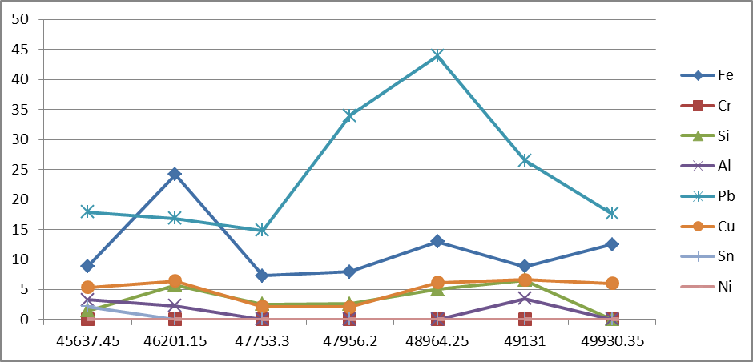

ppm

Total Running Hrs

Viscosity
40⁰C 100⁰C
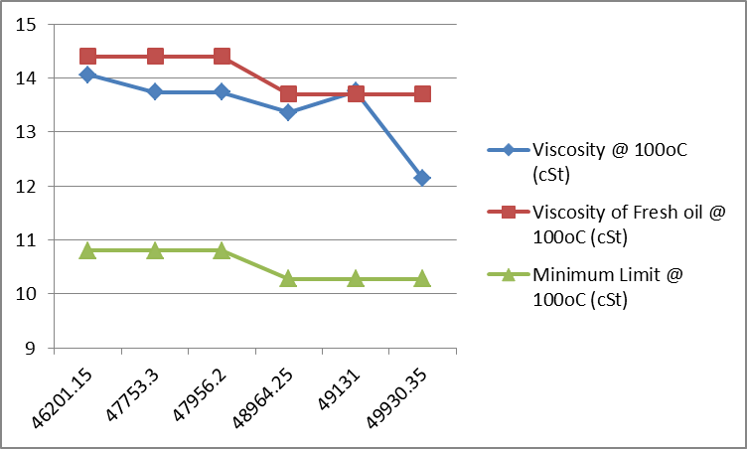
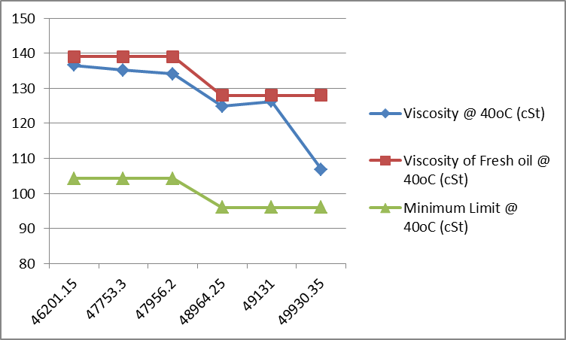

(cSt)
(cSt)
Total Running Hrs

Total Running Hrs

Total Running Hrs
Total Running Hrs

